Tool setup:

Steps to Install Laravel 7 and all needed Software to Launch The Project

## 1. Install XAMPP

First, download the XAMPP from the official website given below.

<https://www.apachefriends.org/download.html>

Laravel 7 requires PHP >= 7.2.5. So download the latest version (7.3.3/PHP 7.3.3).

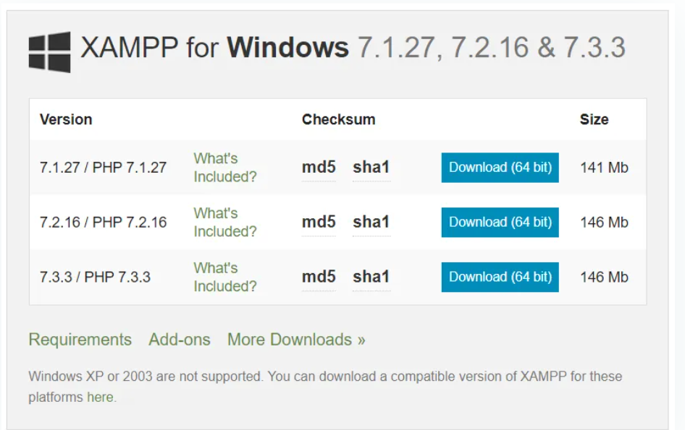

 Next steps Explain the XAMPP installation with the screenshots.

1. Select the components to install with XAMPP. Actually we only need Apache, MySQL, and phpMyAdmin. But here, I have selected all.

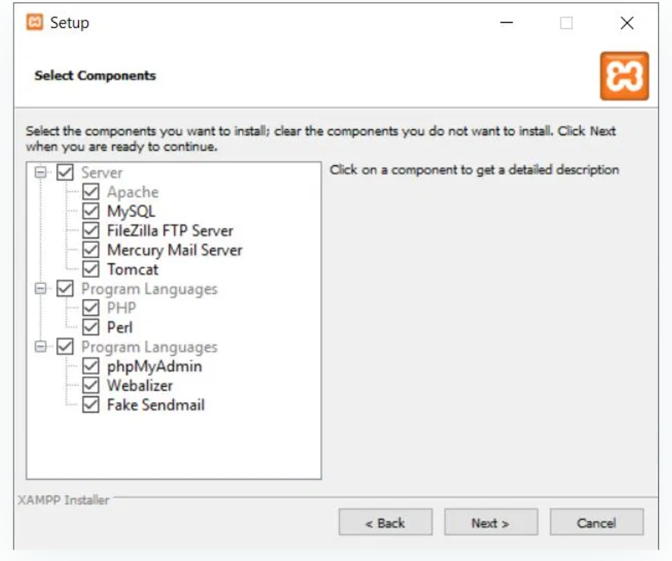

2- Select the installation folder. In default, it will be C:\xampp

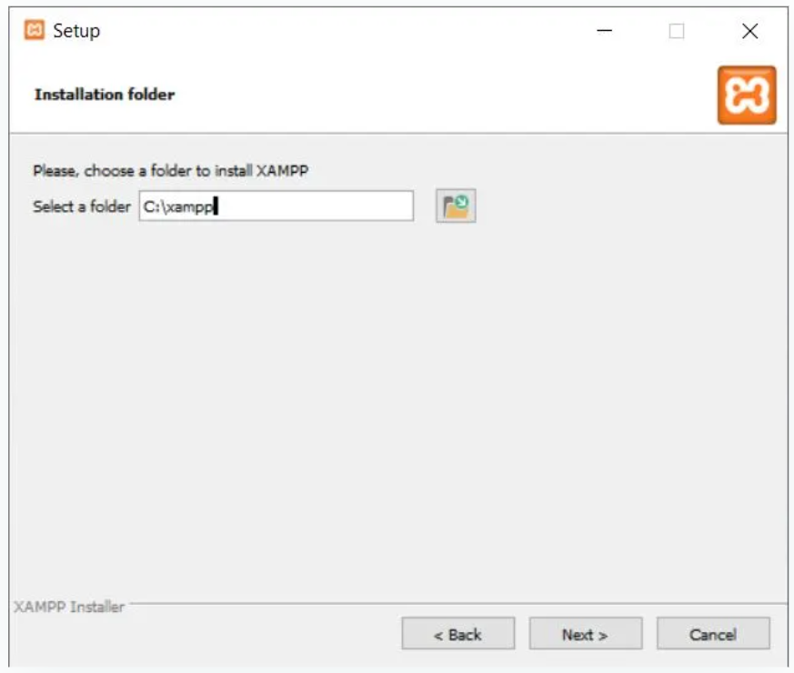

3- Finished and Now start the Apache and MySQL.

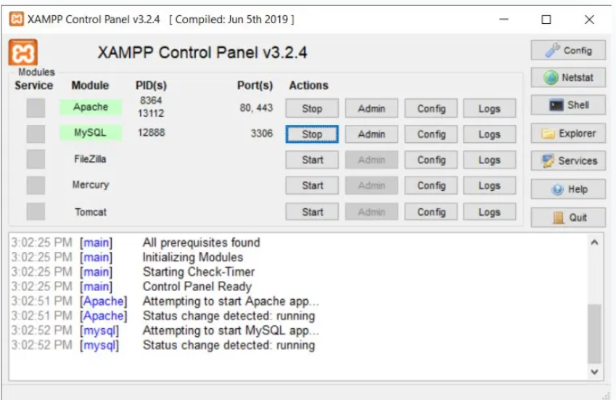

## 2. Install Composer

follow the below URL and download the **Composer-Setup.exe**file.

<https://getcomposer.org/download/> .

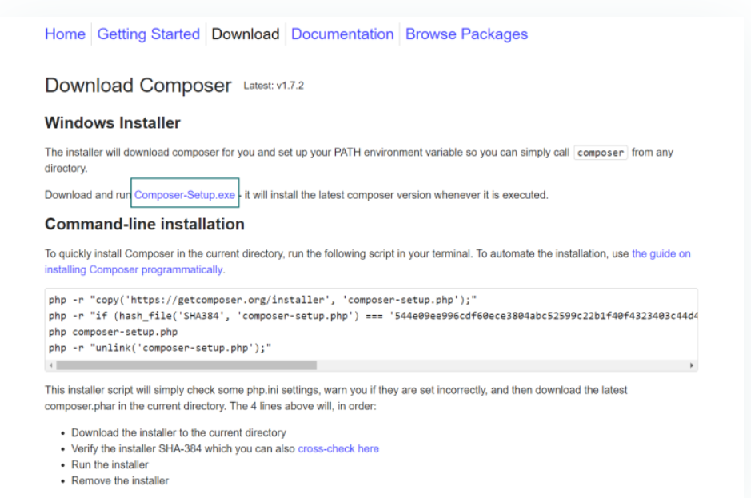

Next figurers are screenshots from the installation steps.

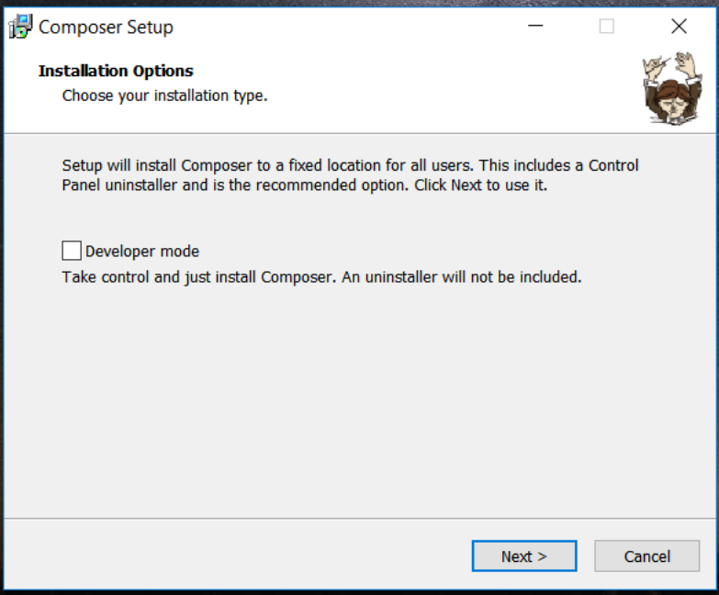

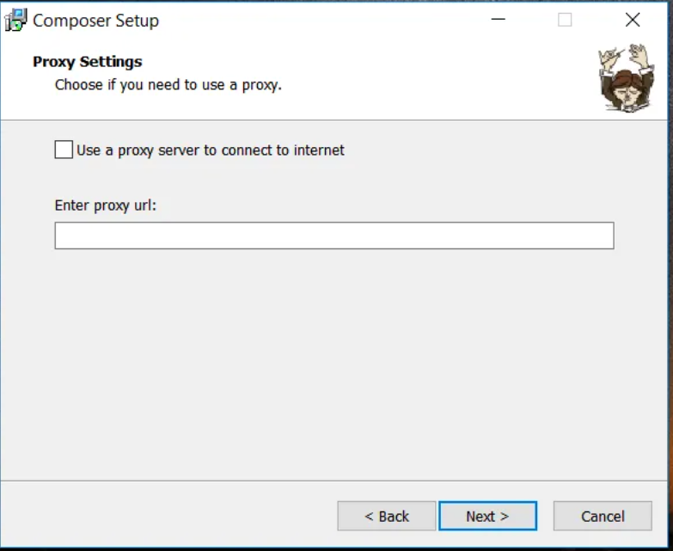

## 3. Install Laravel

## This can be done by running the below command in the **Command prompt**.

composer global require "laravel/installer"

## 4- Create a Database.

## using phpMyAdmin.

* Open the link below. <http://localhost/phpmyadmin>
* Now Enter username and password(As a default, the username will be **root**password will be empty).

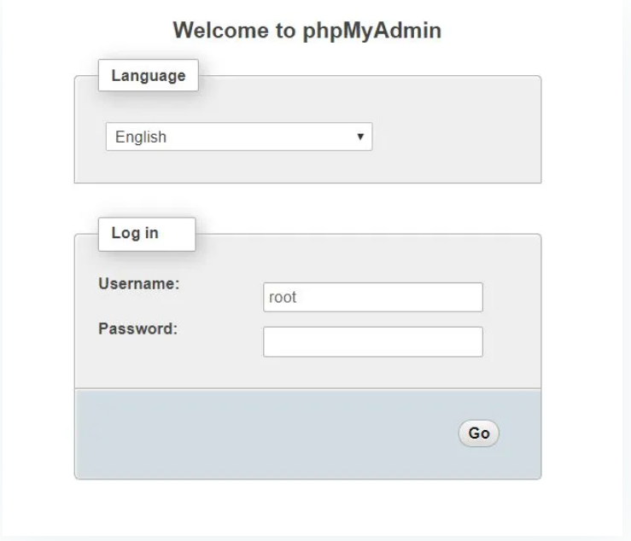

Now you can see phpMyAdmin panel where you can manage all the MySQL databases.

To create a database by clicking **New**from the left menu. **Enter the database name** and press **Create**.

* Click on the **New** tab
* Enter a database name
* Press **Create**

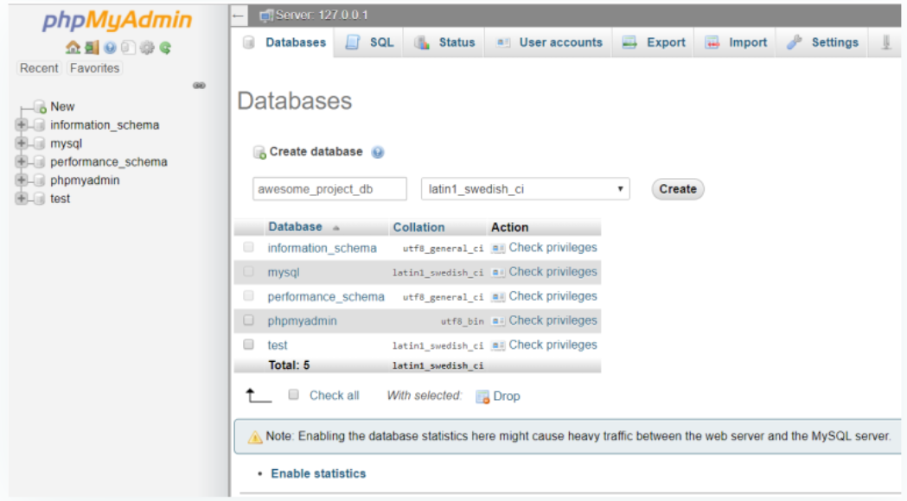

## 5-Modify .env File

## Now open the Project in any editor . recommend using [Visual Studio code](https://www.techomoro.com/installing-visual-studio-code-on-windows-10/) or

## php storm as the source-code editor for working with Laravel projects.

## Check  **.env** file inside the root directory of our project. Add our database details in this file which shown below.

DB_DATABASE=(The database name for the projec – realstatedb)

DB_USERNAME=(Your Mysql username. Default: **root**)

DB_PASSWORD=(Your Mysql password. As a default, blank)

## 

## 6-Migrate Database

## This can be done using the command below.

php artisan migrate

## 7-Running the Application

## Our application can be run using the command below.

php artisan serve

## This will open up a new tab on our browser with the URL below. This is the home page of our Laravel application.

http://localhost:8000

## 